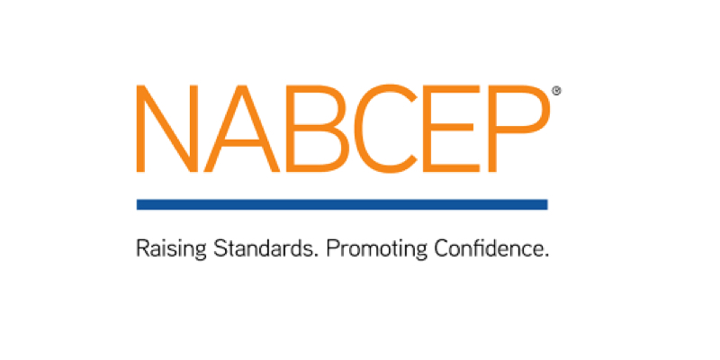
Gordian Energy Systems is delighted to announce that our Steve Beall has earned the solar industry’s leading recognition of installation expertise from the North American Board of Certified Energy Practitioners (NABCEP), and is now a NABCEP PV Installation Professional™. NABCEP is the most highly respected and well established national certification organization for renewable energy professionals. Designation as NABCEP PV Installation Professional is widely recognized to be the most important and meaningful certification of its kind in the solar industry.
“Receiving NABCEP PV installation professional certification is personally very satisfying” said Mr. Beall. “It means that our clients will have the added confidence of knowing their Solar PV system installation will be completed with the highest standards in the industry.”
To earn his NABCEP certification, Mr. Beall was required to first document his relevant education and experience related to solar PV installation. He then had to pass a rigorous exam that covers the breadth of the multi-craft knowledge, skills and abilities required to competently design, install and maintain PV systems.
“One thing you can be assured of when hiring a NABCEP professional and firm is that your solar project won’t be their first,” said Richard Lawrence, Executive Director of NABCEP. “Anyone who makes the considerable effort required to earn this certification has documented their training and experience as part of the eligibility process. They also made a very real commitment to upholding high standards of ethical and professional practice”.
“We are very proud of Steven,” said Bill Cole, President of Gordian Energy Systems. “Steven began his career here as an intern from UMBC. I’ve been watching him grow as a person and as a professional for the past five years. Steven has developed into a key member of our team. We look forward to many years of his contributions here at Gordian Energy Systems”.

